**Generate MRPM Reports**

1. GPRO Interface

GPRO will transmit data on every 1st calendar day of the month.

Incoming folder:

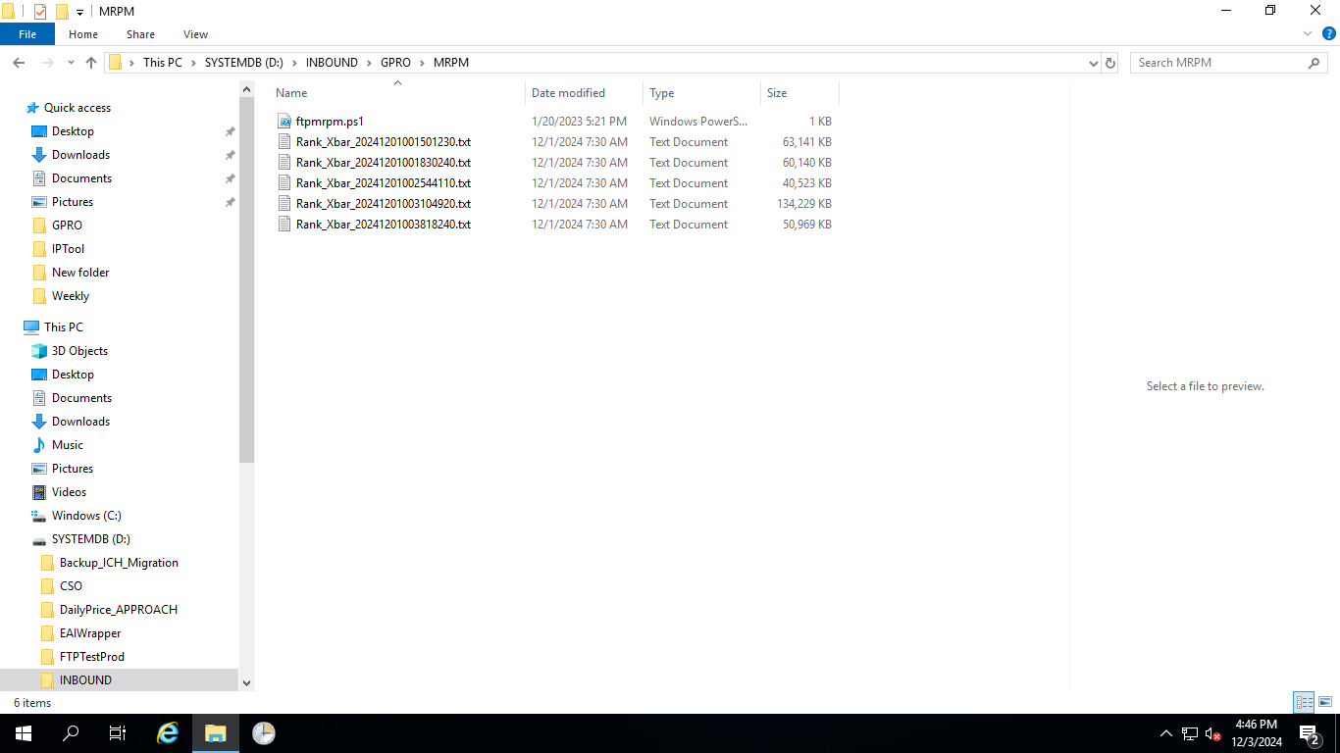

1. APPROACH Jobs
   1. Windows Scheduled Job “GetMatDataFromGPRO”

This job runs at 7.30am on every first calendar day of the month. It will grab GPRO interfaced file and put into D:\MRPM\file folder in DB server.

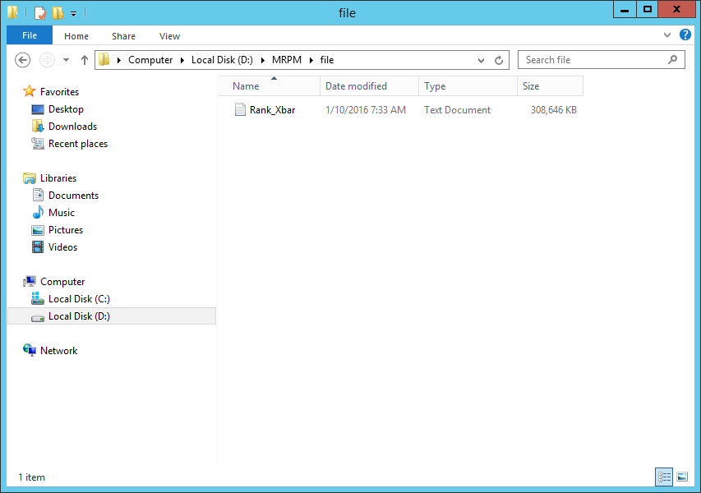

**Note**: If this file is not found, check in GPRO staging server to see if it is there. If not, log an incident with GPRO S&M team via GSD.

* 1. SQL Job “SRPC-Monthly-GetDemand-Planning”

Ensure this job is run successfully on that day at 8am. And that the report is available in APPROACH website.

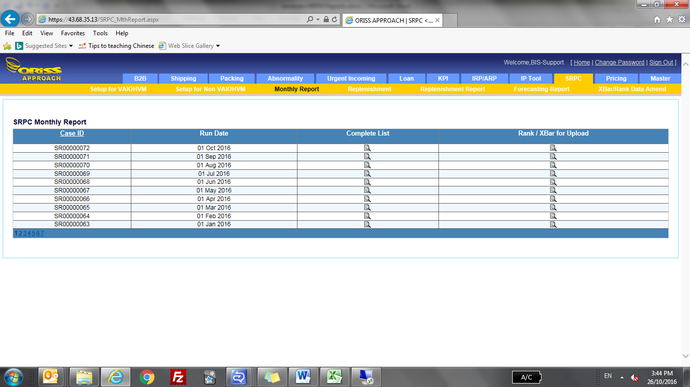

* 1. SQL Job “MonthlyRPMaster”

Run this job manually after ensuring that “SRPC-Monthly-GetDemand-Planning” job runs successfully.

1. Generate Report

**Note**: Ensure that these are available and installed in your notebook:

1. Folder “RankXBarUpdate” and

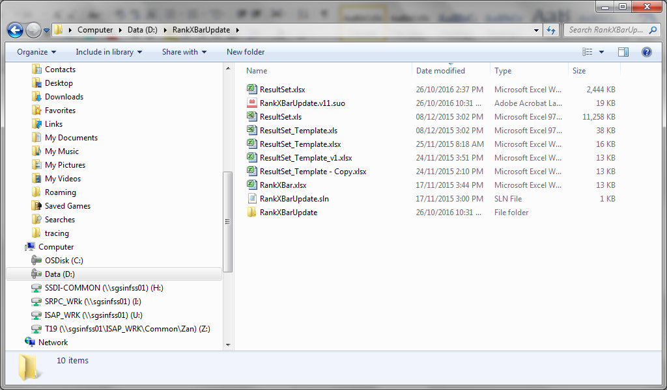

1. Microsoft Visual Studio 2012 Shell(Integrated)

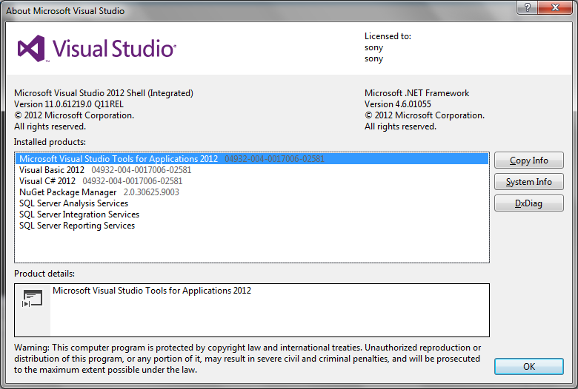

Open and run program “RankxBarUpdate.sln” in Microsoft Visual Studio 2012.

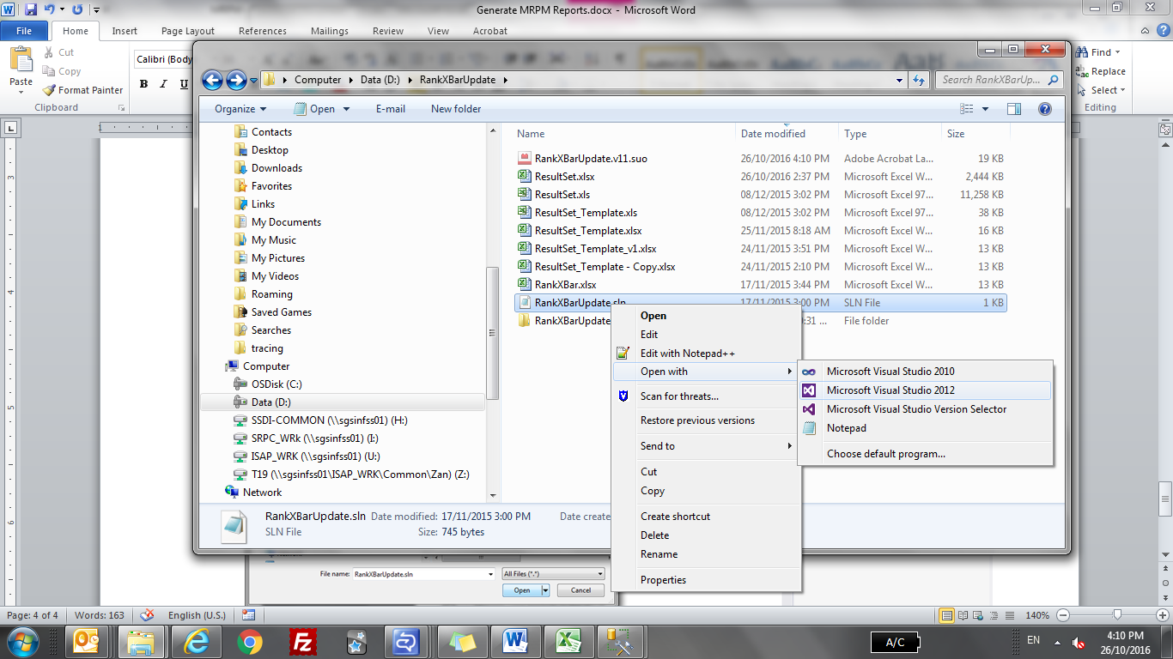

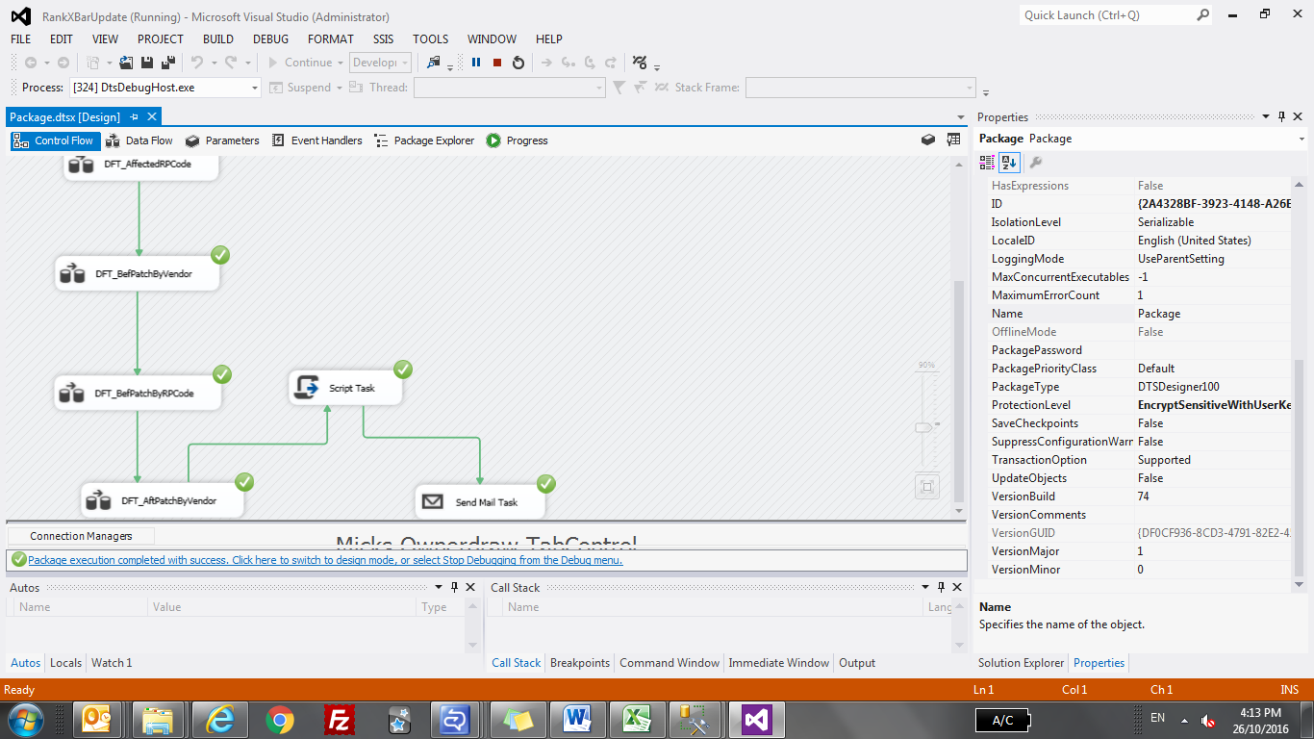

You can find “ResultSet.xlsx” report in folder D:\RankXBarUpdate.

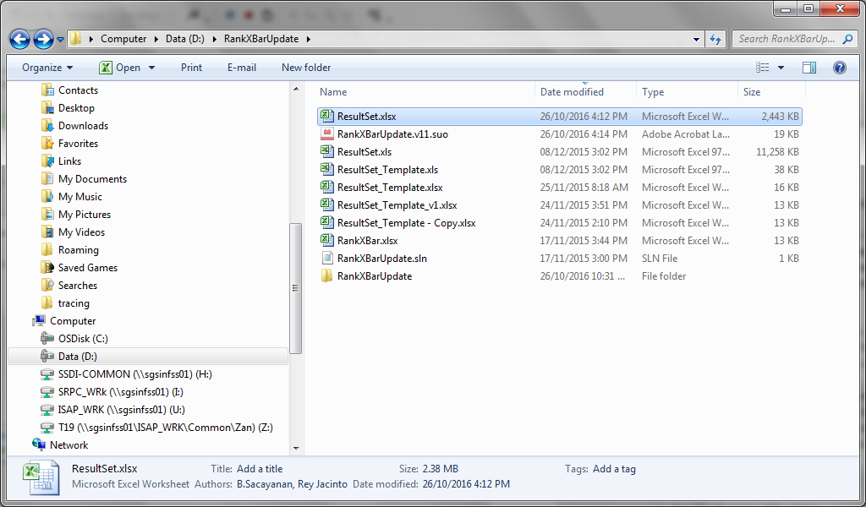

1. Email to RPP Team

After report is generated, an email needs to be formatted and sent to RPP team.

An example is shown below. Highlighted areas are the ones in email that need to be changed before sending out.

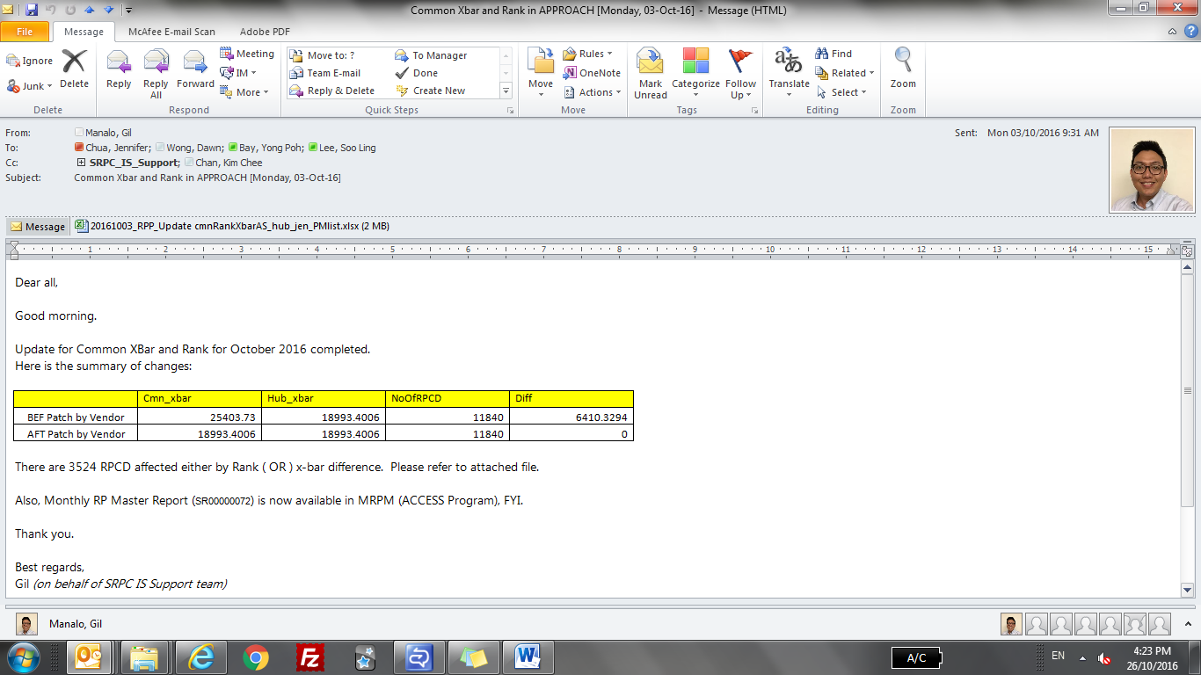

RP Master Report number is taken from Monthly Report webpage.



Record count taken from Affected RPCD tab in ResultSet.xlsx

Taken from Summary tab in ResultSet.xlsx

Ensure Diff is 0 in AFT Patch by Vendor